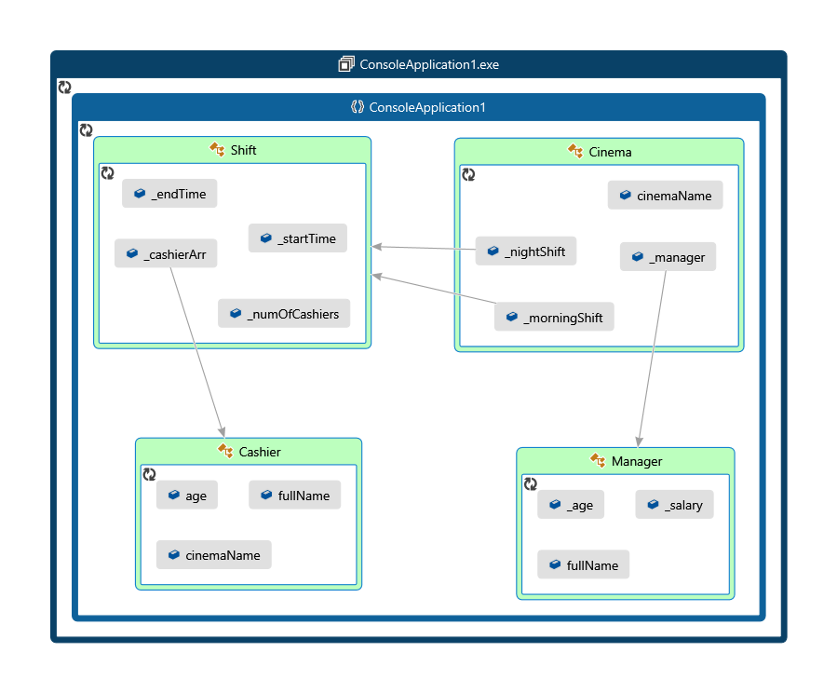

**Template of cinema objects (class)**

class Cinema {

public cinemaName: string;

private _manager: Manager;

private _morningShift: Shift;

private _nightShift: Shift;

}

**cinema object (example)**

{

CinemacinemaName: "JB-Cinema"

manager:

fullName:"Sean"

_age: 20

_salary: 20000

_morningShift

_cashierArr: Array(3)

0: Cashier

{

"_age": 21,

"_cinemaName": "JB-Cinema",

"fullName": "Bob"

}

1: Cashier

{

_age: 23,

_cinemaName: "JB-Cinema",

fullName: "Alice"

}

2: Cashier

{

_age: 27,

_cinemaName: "JB-Cinema",

fullName: "Clarc"

}

_nightShift:Array(4)

0: Cashier

{

_age: 21,

_cinemaName: "JB-Cinema",

fullName: "Anna"

}

1: Cashier

{

_age: 23,

_cinemaName: "JB-Cinema",

fullName: "Netanel"

}

2: Cashier

{

_age: 27,

_cinemaName: "JB-Cinema",

fullName: "Boris"

}

3: Cashier

{

_age: 27,

_cinemaName: "JB-Cinema",

fullName: "Yaniv"

}

}